Q1. Configuration of Network Devices using Packet Tracer (Hub, Switch, Ethernet, Broadcast)

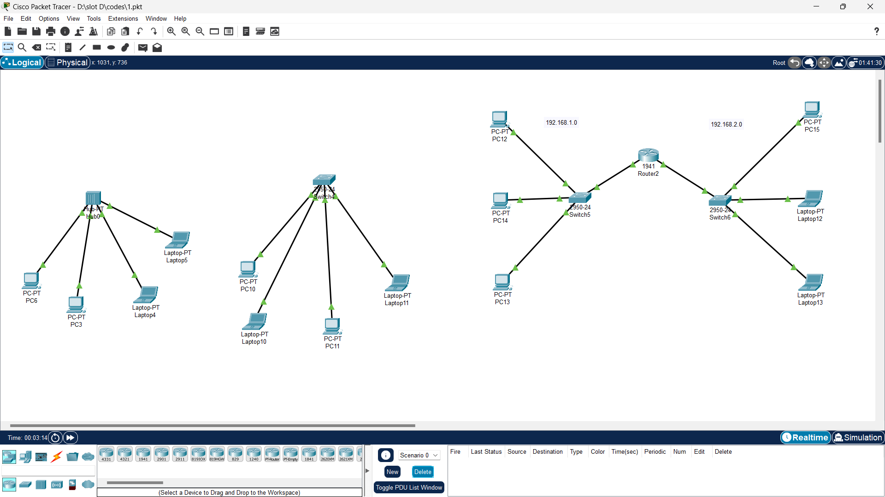

Q2. Configuration of Topologies using Packet Tracer (Star, Mesh, Tree,)

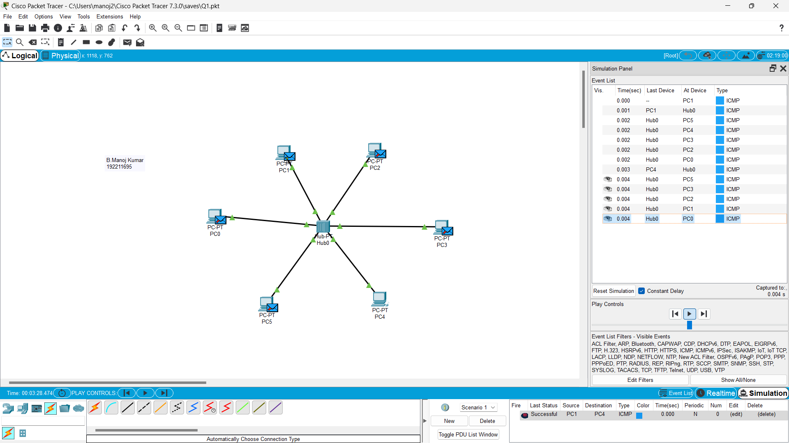

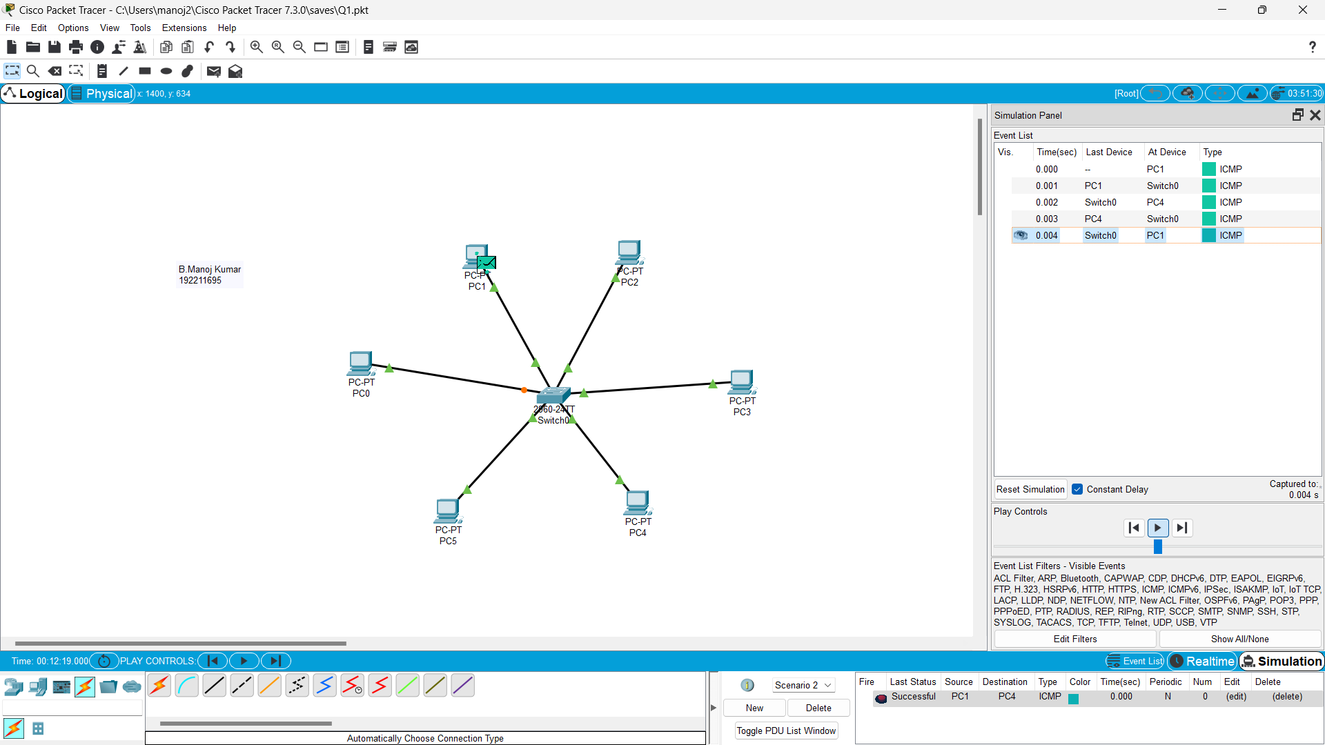

Q3. Configuration of Topologies using Packet Tracer (Bus, Ring, Hybrid)

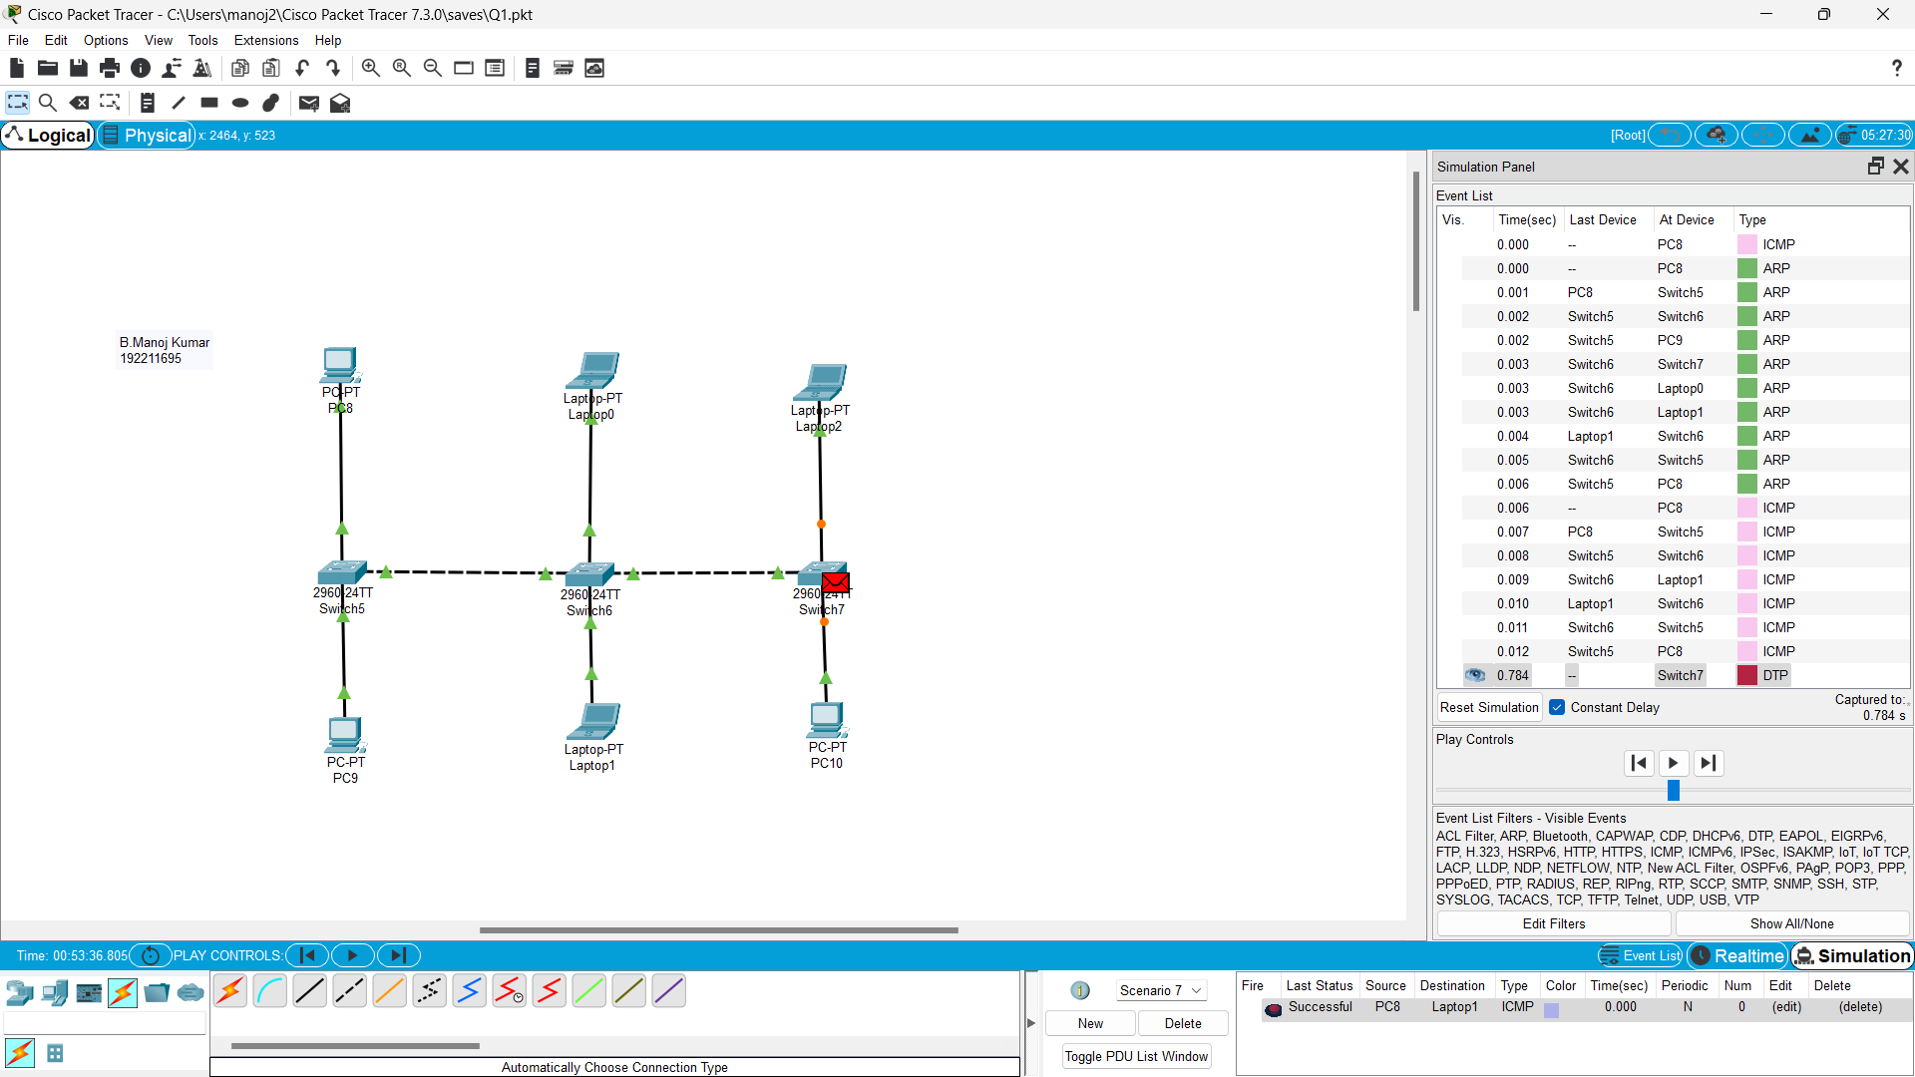

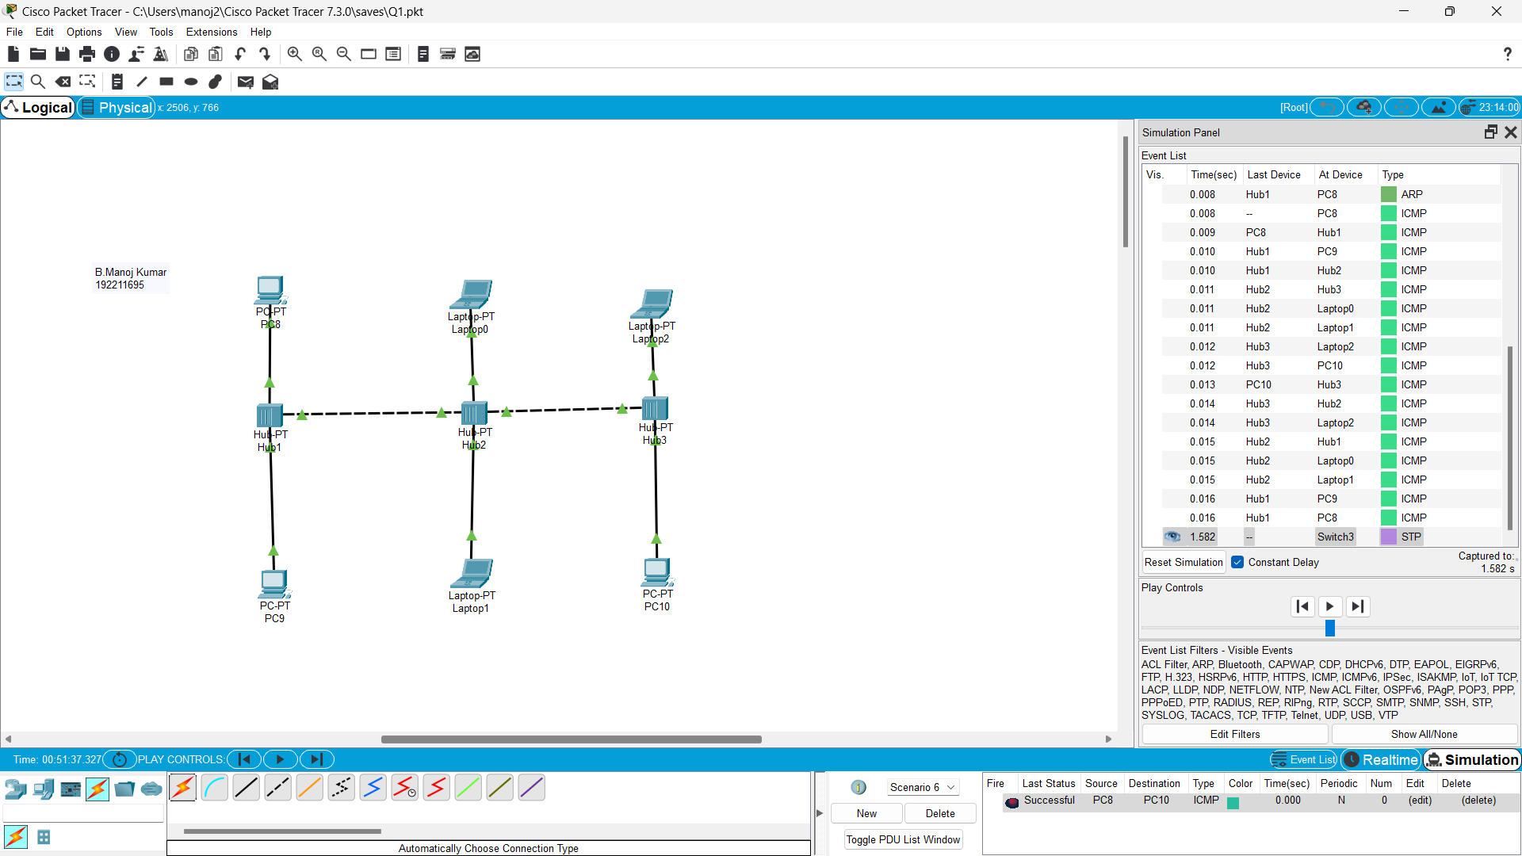

Q4. Data Link Layer Traffic Simulation using Packet Tracer Analysis of CSMA/CD& CSMA/CA

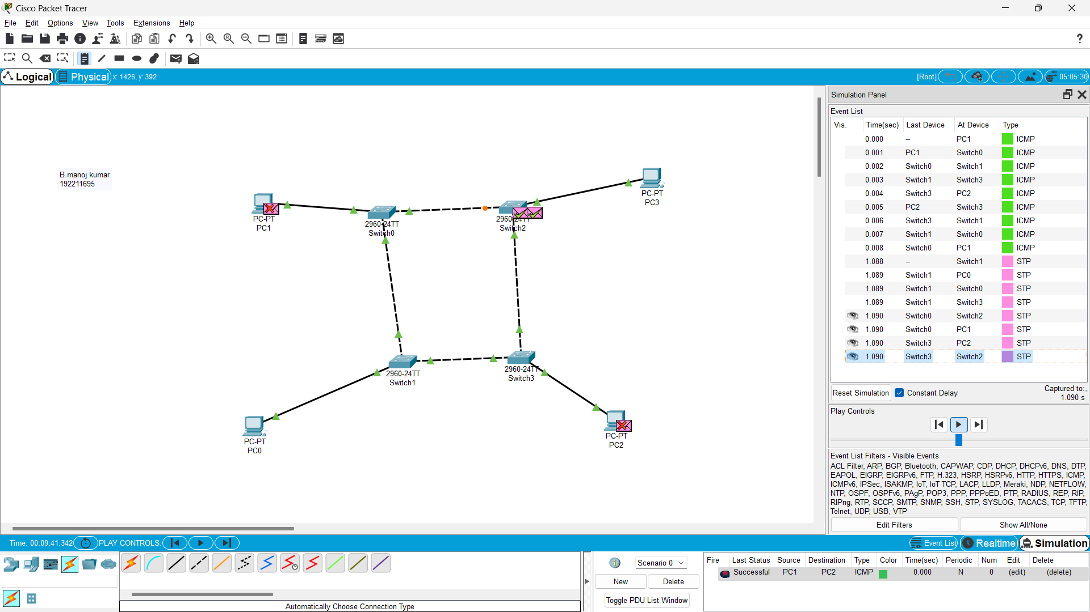

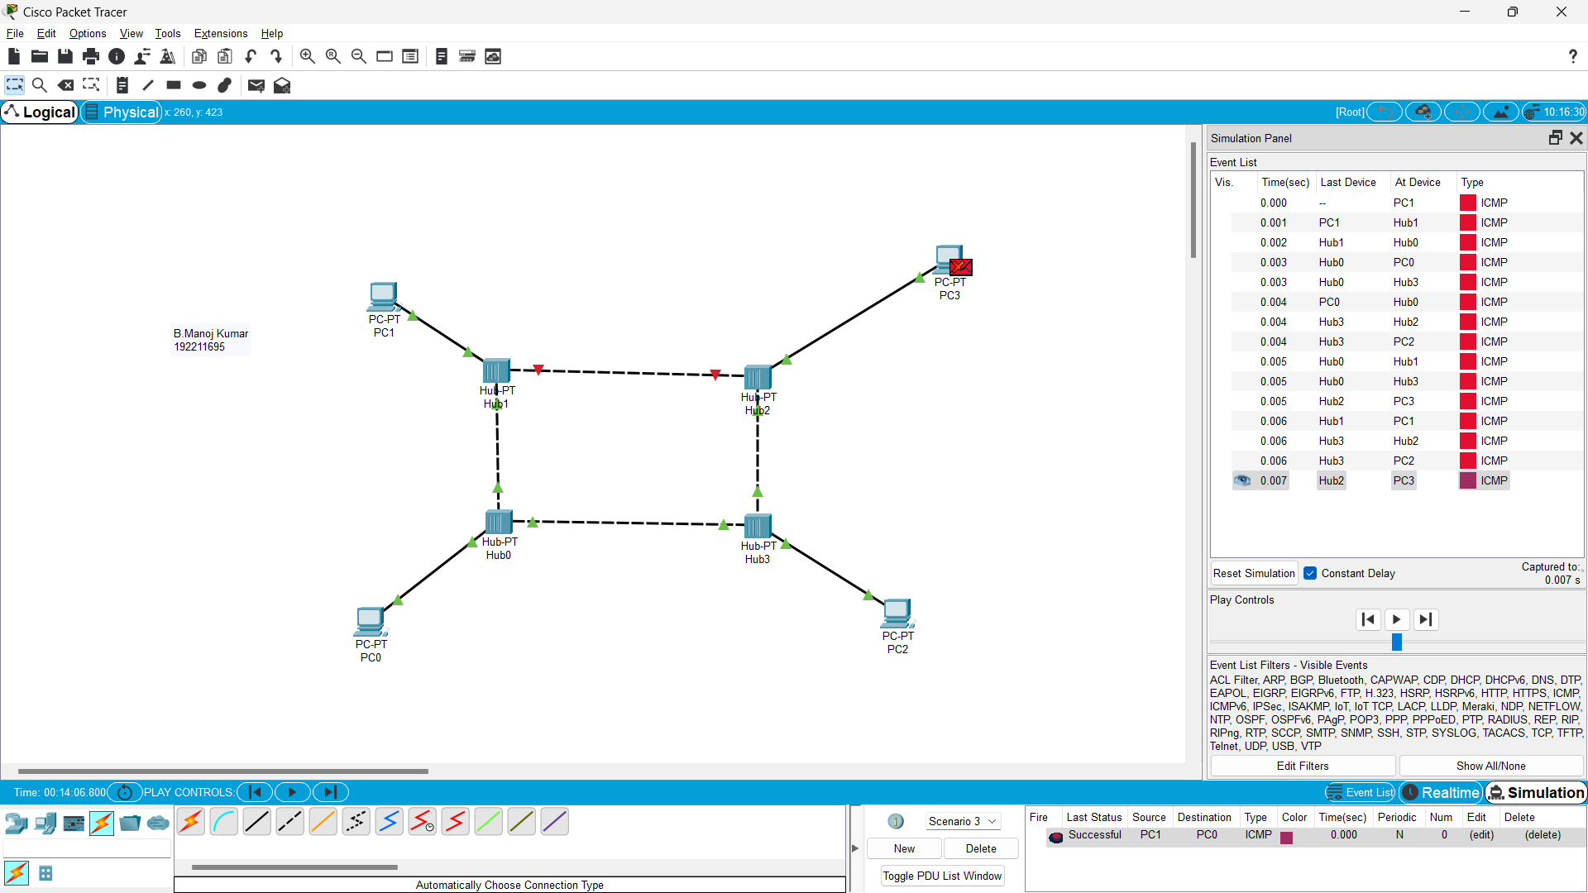

Q5.. Data Link Layer Traffic Simulation using Packet Tracer Analysis of ARP

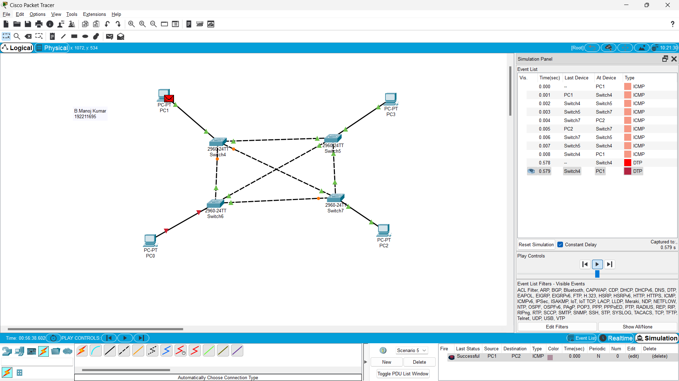

Q6. Static Routing using Packet Tracer

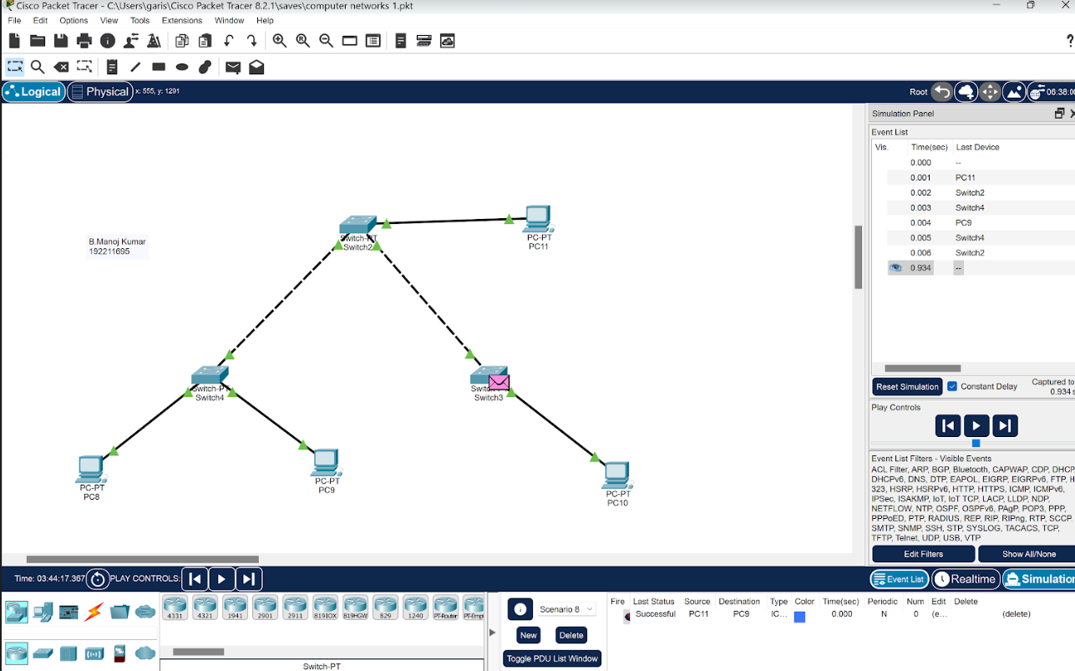

Q7. Dynamic Routing using Packet Tracer ( OSPF)

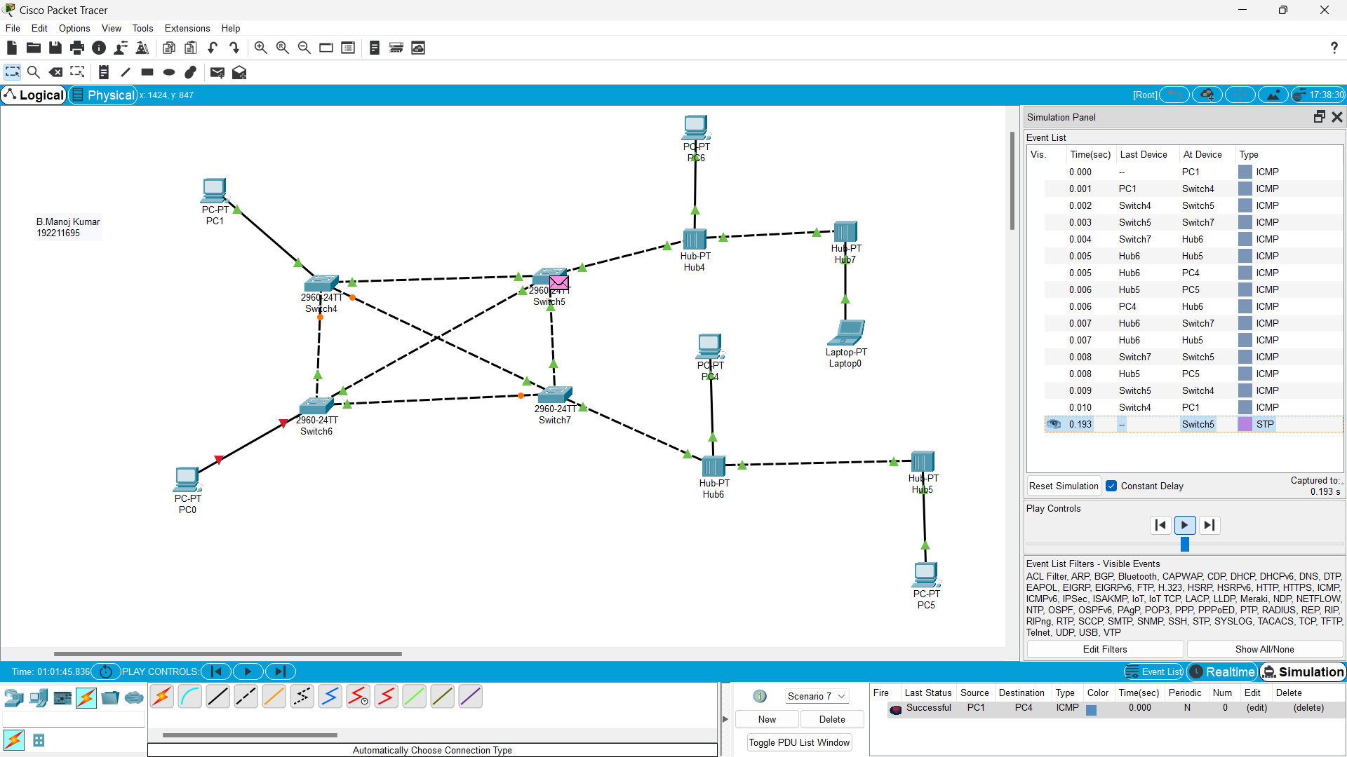

Q8. Subnetting – Class C Addressing

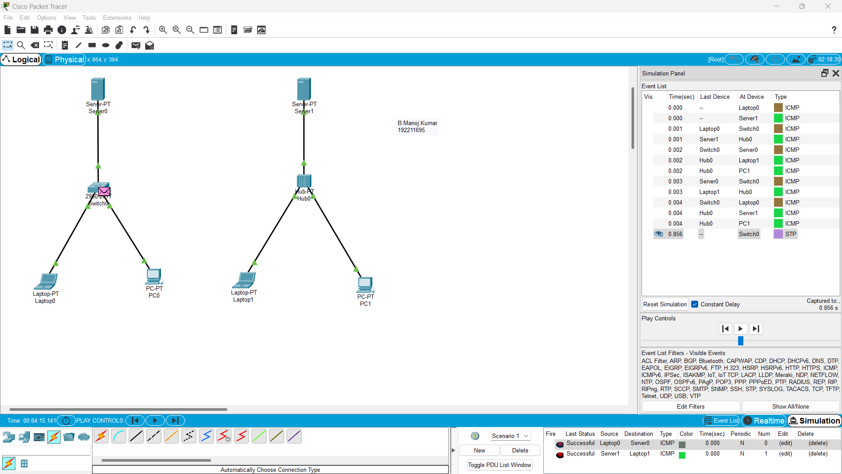

Q9.Functionalities of TCP, UDP

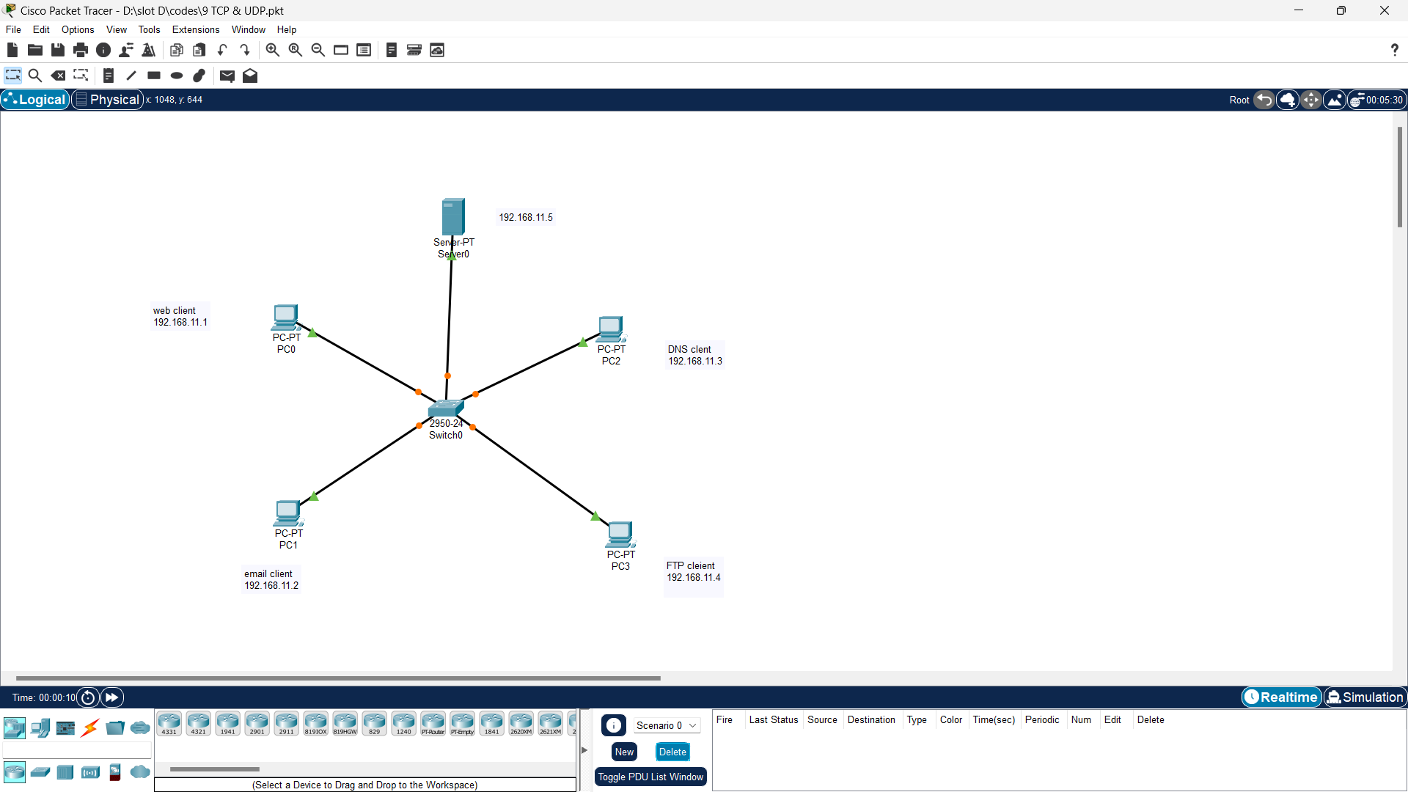

Q11. IOT Based Smart Home Using Cisco Packet Tracer

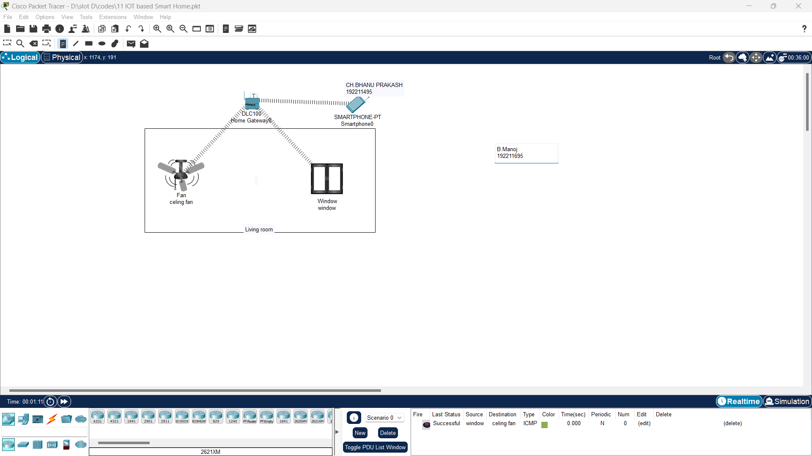

Q12. Smart Garden in Cisco Packet Tracer

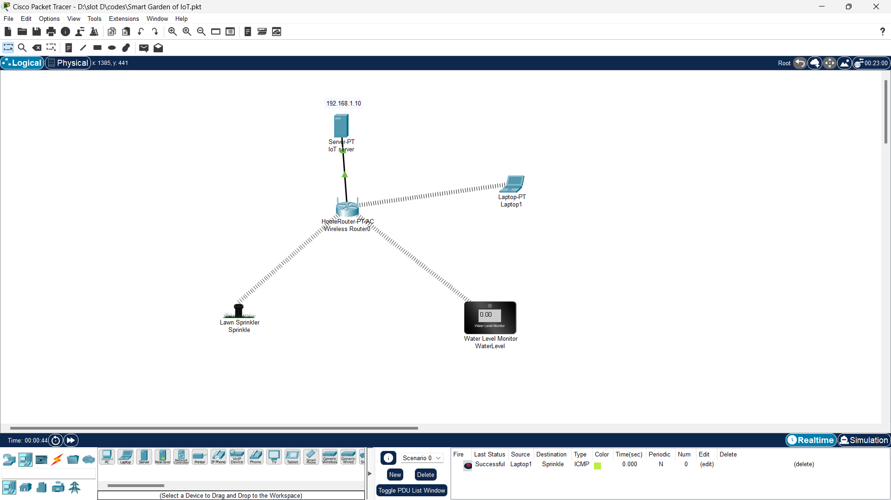

Q13. IOT Devices in Networking Using Cisco Packet Tracer

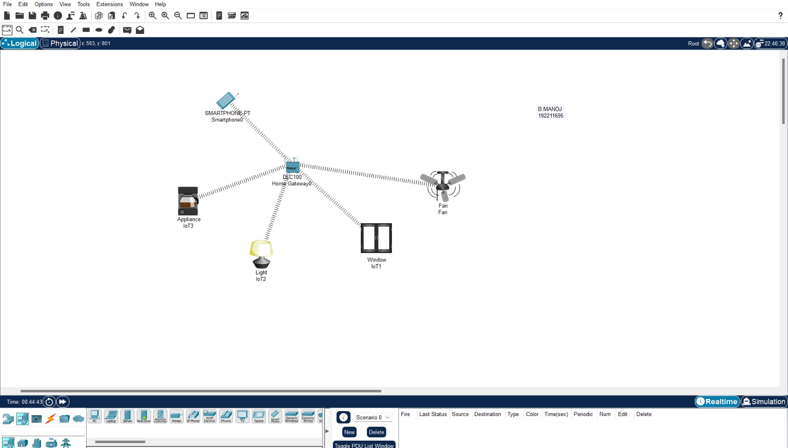

Q14. Simulating X,Y,Z Company Network Design

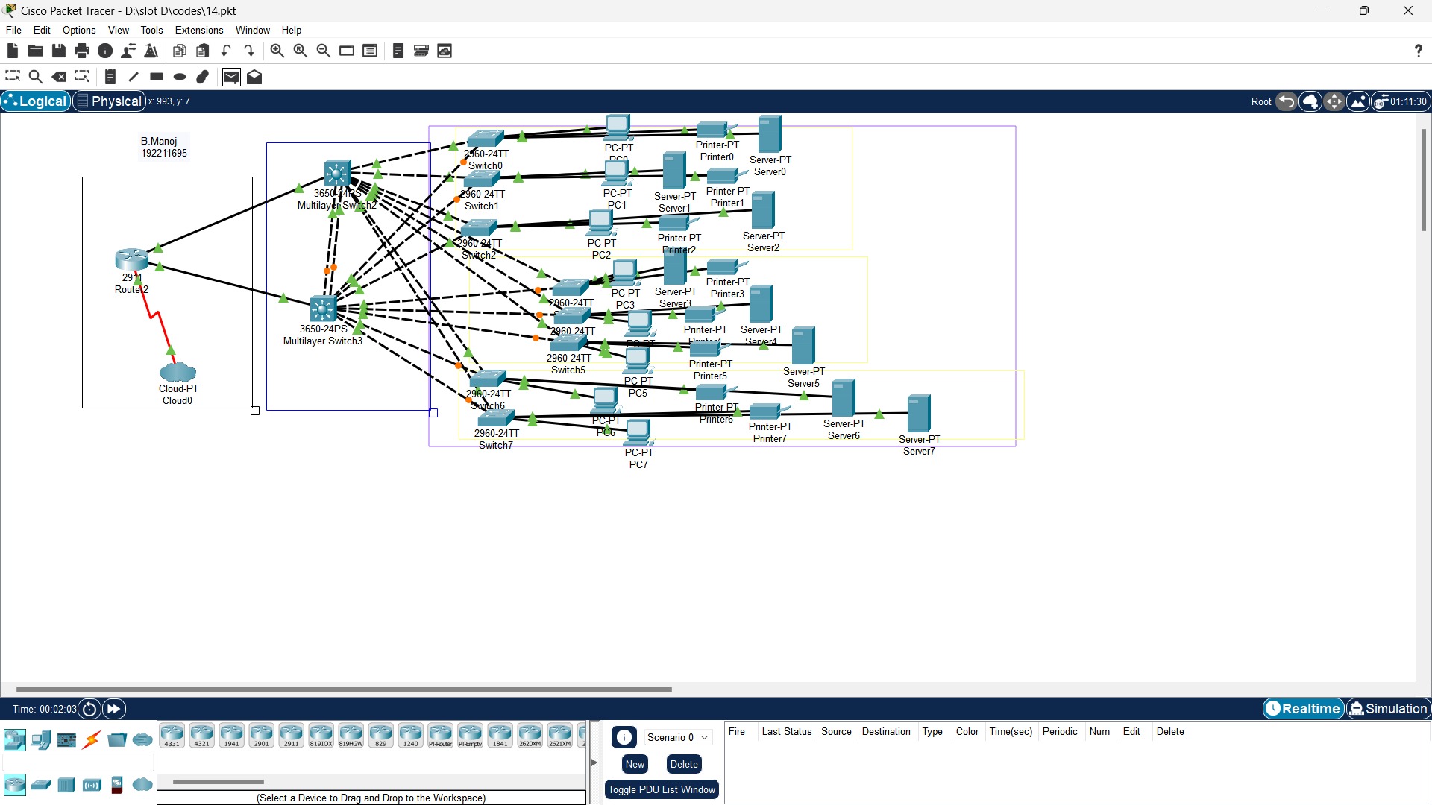

Q15. Make Computer Lab in Cisco Packet Tracer

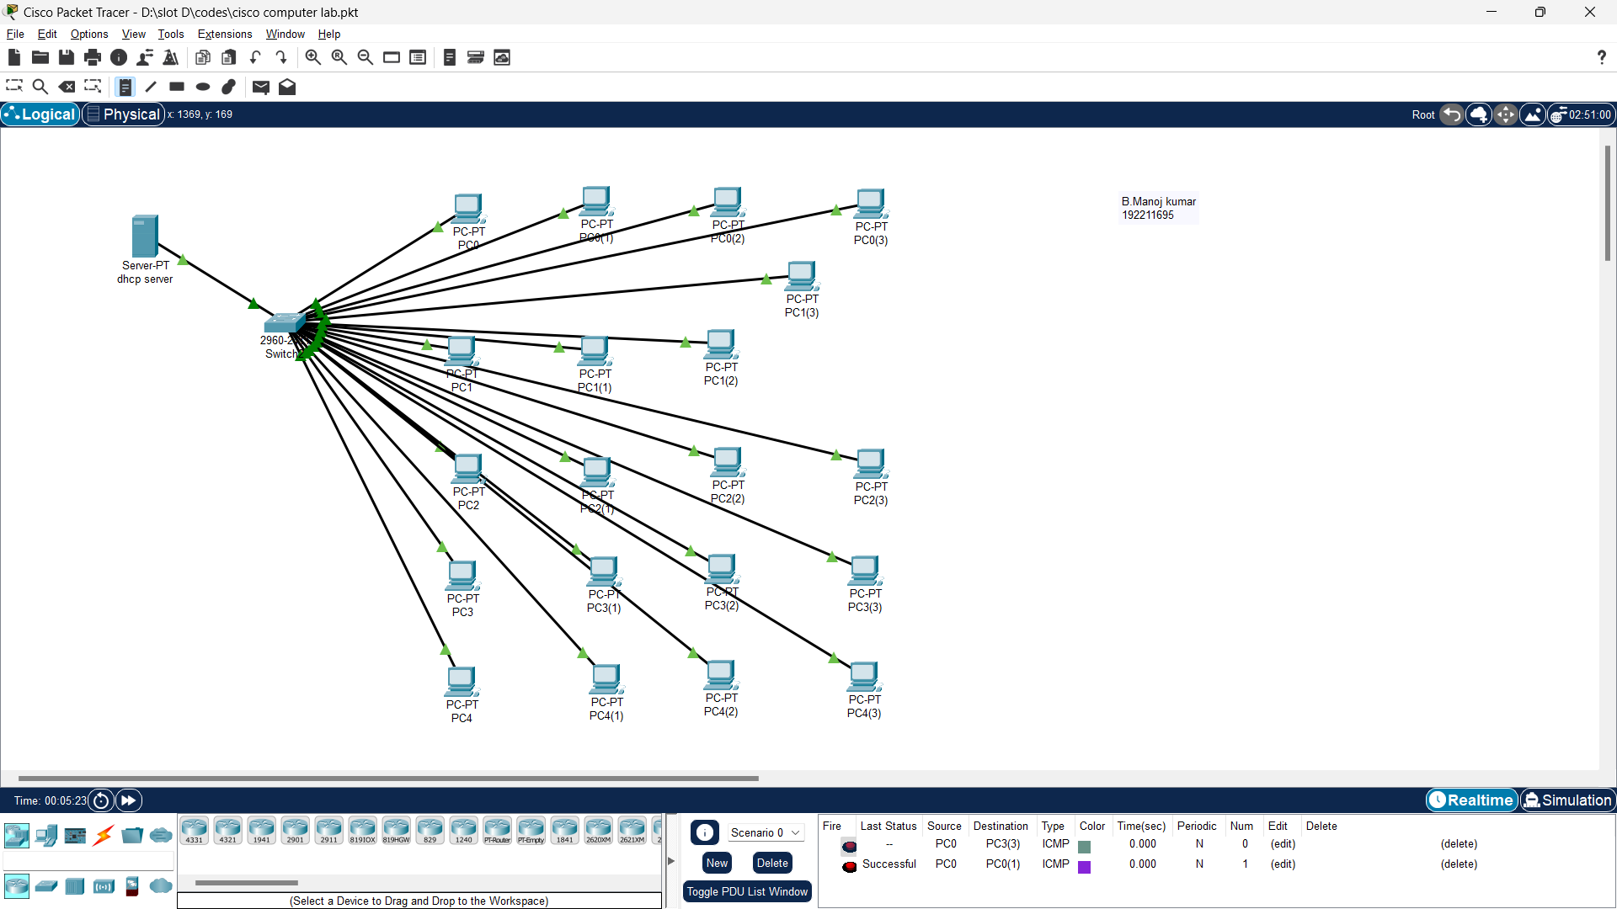

Q16. Simulate a Multimedia Network

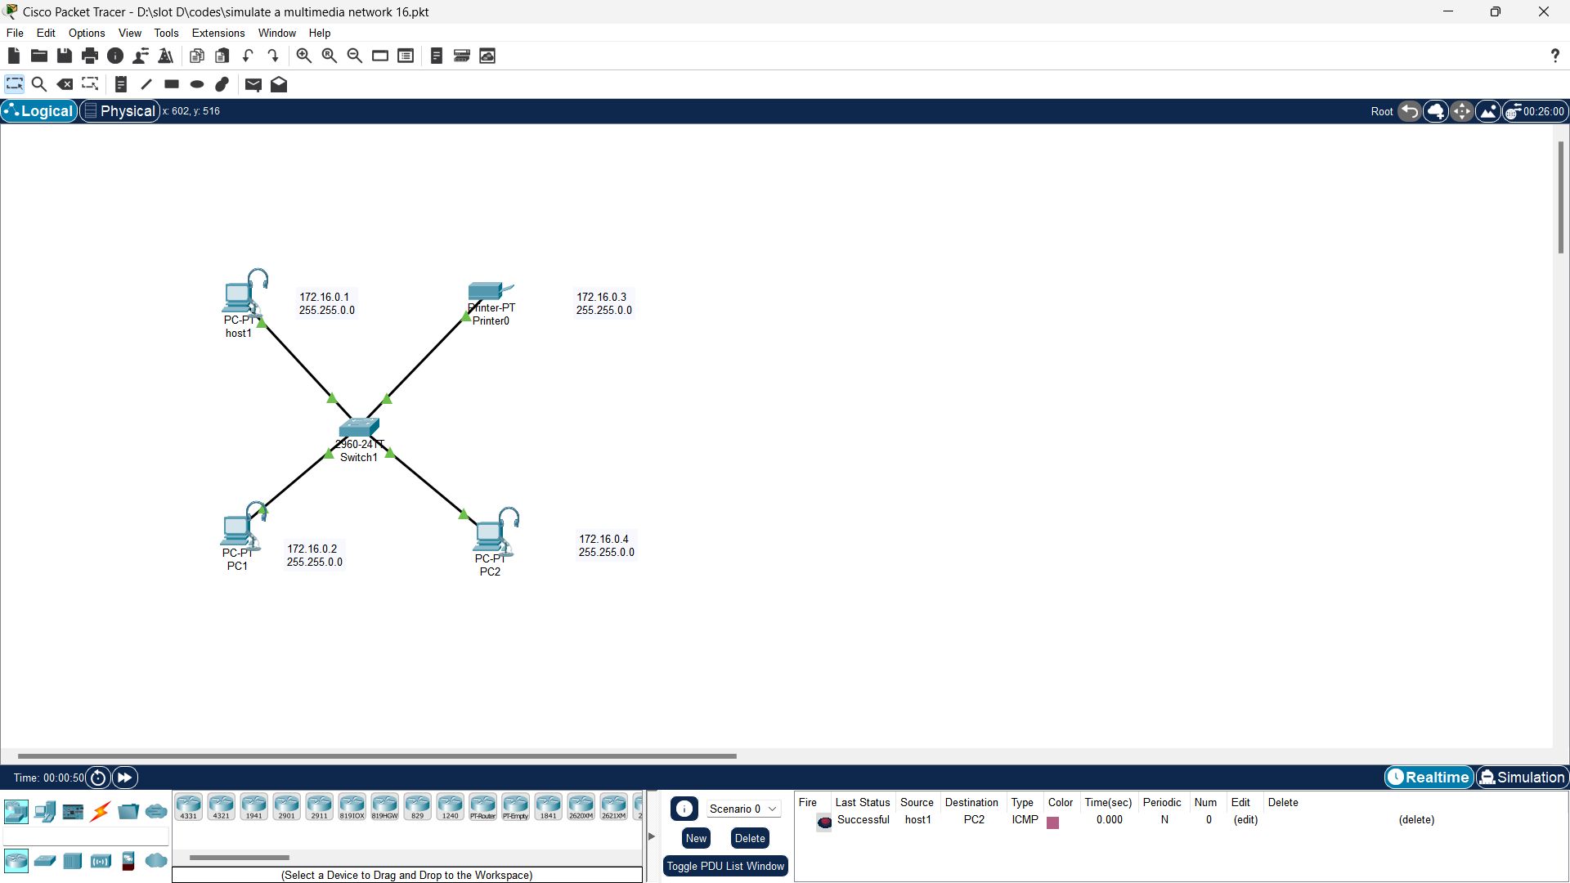

Q18. IOT Based Smart Home using WPA Security & Radius Server

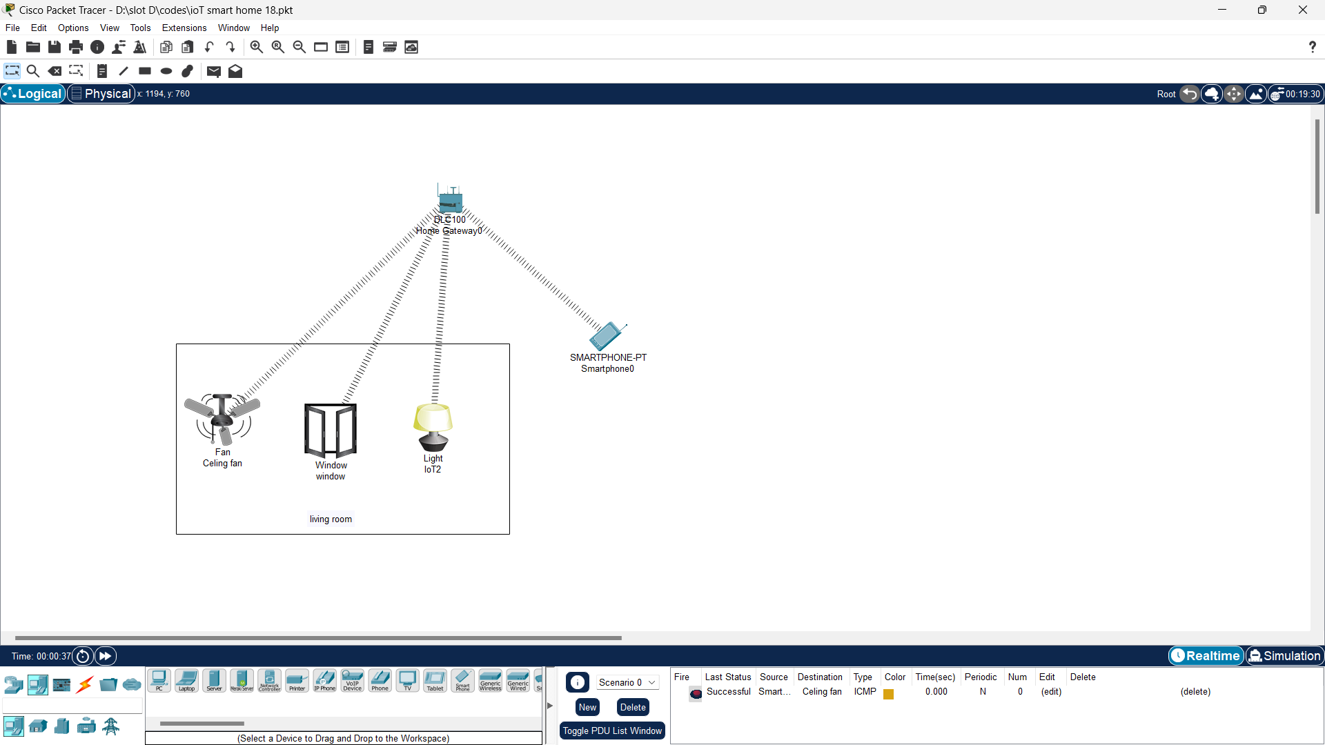

Q20. Control of Fan, Light, Window & Application of Using Cisco Packet Tracer

